**Introduction to Debugging**  
* When an application crashes or behaves in a way we didn’t expect, we have to figure out where the bug occurs in the application code.  
* Fortunately we can use a really powerful tool to help us,   
called **Debugger**.  
* Using a debugger, we can see what’s happening as the application runs and we can stop execution at a specific line of code and examine the state of the application. We can change the values of the variables on the fly and set Watchpoints to help us understand where we’ve gone wrong.  
* We’re going to learn how to use **IntelliJ’s IDE Debugger**.  
* Just a few caveats before we begin:  
=> If you want to see what’s happening inside a class or a method, then we have to have the source code for that class or method.   
=> When debugging our own application code, that’s not a problem but when we want to see what’s happening inside a class that belongs to a Third-party library and we haven’t got access to the source code, then that’s going to make it a lot harder.  
=> In those cases the best that we’ll be able to do is examine what values were passed into a method and what value is returned from the method.  
=> Related to that, to use the debugger with a class, the compiled class files must contain debug information. With our application that’s not a problem but Third-party class files usually don’t add it. Some libraries do offer 2 versions, one without debug information, one with the debug information.  
=> We would be using the debug version during development.  
* When using the debugger, our applications will run slower than it usually does because of the extra processing that has to take place back in the debugger. And because of that, using a debugger to track down a Threading issue for example, can sometimes be challenging. The debugger can mask Threading issues because the timing of the application isn’t the same when running in debug mode.  
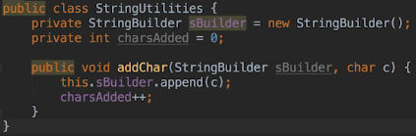  
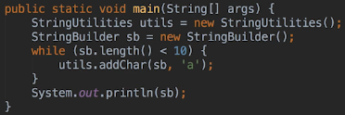  
  
  
* When debugging, a socket is opened because the debugger attaches to the application and communicates with the application, using that socket.  
* If we want to see what’s happening inside our application, we need the application to stop running or suspend at some point so that we can examine that state.  
* We tell the debugger where we want the application to suspend by setting a **Breakpoint**.  
=> CTRL + F8 or click next to the line number to set a Breakpoint.

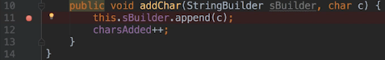  
* **When an application suspends at a Breakpoint, keep in mind that the line of code has not been executed yet**.  
* But it isn’t always the case that when the application suspends, the highlighted line of code hasn’t been executed yet. It’ll depend on the context. For Breakpoints, though, it has not been executed.  
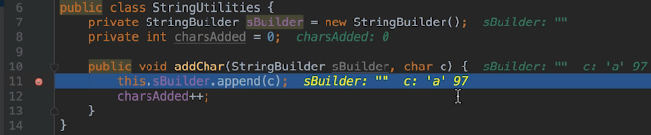  
* This is telling us the current values of the parameters we passed to this method.  
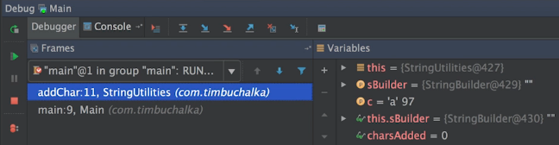  
* The Frames sections on the left shows the execution Stack Trace. So each time a method is called, a Frame is added to that Stack Trace.  
* In this case there are 2 frames on the stack. The first method called is at the bottom which is the main method which was called by the Java Runtime. The main method then called the addChar() method from our StringUtilities class and that’s this next frame which is currently highlighted in blue.   
* The top frame is the method that’s currently executing.  
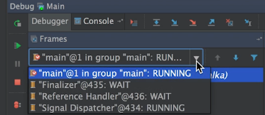  
* The dropdown shows all the Threads that are executing and their states. To see the Stack Trace for another thread, we just have to select it from the dropdown.  
* This can be useful when you’re trying to debug a multi-threaded application. Even more conveniently, we can even add a Thread’s pane to the frame area by pressing the restore Thread view button. It’s located to the right of the pane.  
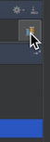

* The Variables section shows instance variables, the method parameters and also any local variables that have been declared before the suspension point.  
* Instance variables are in the THIS.  
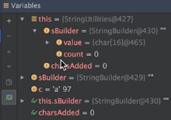  
* The charsAdded is shown under THIS but it’s also shown on its own line further down, shown outside of THIS as a convenience because it’s used in the method in which we currently suspended.  
* We’ll see later that we can also use watches to make seeing some values more convenient.  
* IntelliJ marks parameters with a P.  
* One of the parameters has the same name as the instance variable and you might get more of a clue into the bug if you haven’t already.  
* The last 2 items are marked with glasses. These are watches that IntelliJ automatically sets.

**More on Debugging**  
* **Show Execution Point** => returns the editor to where the application was suspended and it. Didn’t really do much now because I was already on that line. But if we click on another file and then click the button, it takes us back to the current execution line. Basically to the line corresponding to the current Breakpoint. It’s a shortcut to get back to where the Breakpoint is.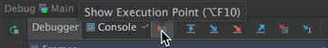  
* **Step** **Over** => will advance the execution point by one statement and it won’t show us what’s happening inside any methods called by the statement. We use this when we don’t care about what’s happening in any methods called by our code.  
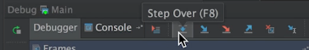  
* **Step Into** => will step into any methods called by the next statement that’s executed. So the application will suspend on the first line of the first called method. We use this when we wanna see what’s happening inside any methods called by our code.  
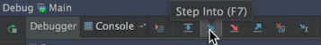  
* If we use it now, we can see the debugger didn’t step into the append() method so it behaved much the same as the Step Over button. But this happened because the StringBuilder append() is a method of the Java Development Kit.  
* Many debuggers, including the IntelliJ debugger, won’t suspend within JDK methods because they assume that developers aren’t interested in seeing what’s happening inside those methods. The JDK isn’t bug-free but most of the time it won’t be the source of a bug.  
* The situation could also arise when we’re dealing with Third-party libraries.  
* If you want the debugger to suspend within a JDK method or another method that normally it would skip over, we have to use the Force Step Into button.

* **Force Step Into** => will force the debugger to step into a JDK method and suspend.  
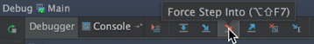  
* **Step Out** => run the rest of the method and return to the caller and suspend.  
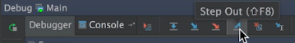  
* In this case the caller will be highlighted but it has already executed.  
* **Drop Frame** => allows us to effectively time travel into the past and what I mean by that is it lets us rewind the application by one frame.  
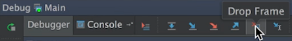  
* If we were to rewind the frame here, we’d actually jump back to the main method as if the addChar() method had never been called. The application would be suspended on the line that called the method.  
* The important note is that we can’t rewind everything. For example network traffic, database changes and changes to static and instance variables won’t be undone. Only changes to local variables will be reverted.  
* So some developers use it to try out different code paths without having to restart the application. But to be honest most of us will probably never use it.  
* **Run to Cursor** => The application will run and when it reaches the line where the cursor is located, it will suspend.  
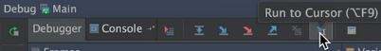  
* Let’s say we have a method that’s 100 lines long and we suspended on line 20 and we want to run to line 55 and then suspend again. Now we could set a breakpoint on line 55 but setting a lot of breakpoints can make future debugging session a bit of a pain. And also if you forget to remove them, the application will suspend in places we weren’t expecting. So unless we actually think we’re going to want to suspend at that line 55 again, it would be better to put our cursor on line 55 and use Run to Cursor.  
* **You can use all these functionalities from the menu => Run**.  
* What do we do though if we suspended and we found the bug?   
* We don’t want to step over or into or out, we just want to get out of the debugger.  
=> You can just stop the debug session as we’ve been doing, but it’s not always a good idea. For our little application it’s fine but for an application that’s perhaps connected to a database or that has opened up a network connection or has any type of cleanup that it needs to do, it’s better to run the application to the completion and we do that by pressin on the **Resume** button on the left.  
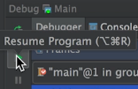  
* If we’ve set other breakpoints, the application might suspend again and that’s why it’s good to keep breakpoints to a minimum and use Run to Cursor in most cases.

* It can be easy to accidentally press the RUN program button when we want to resume the program. Doing so runs an entirely different instance of the application. You can click down here to get back to the debugger.  
  
* If you’re finding that you’ve got a lot of breakpoints and you want to get rid of some of them, there’s a way to see all breakpoints in our application.  
* **Run** => **View Breakpoints**  
* We can also click this button.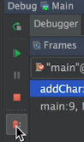

**Field Watch Points**  
* If we step over once:  
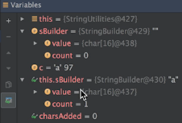 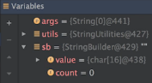  
* This tells us we’re updating the wrong variable.  
* We actually wanted to update the StringBuilder passed to the method.  
* So the loop is never going to terminate.  
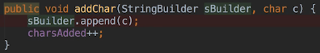  
  
* **Watches** => these variables with glasses next to them. They’re a feature of IntelliJ debugger. Watches always appear in the variables pane and they’re updated as the application runs. This is a convenient way to watch what’s going on with variables of interest.  
* It may not seem like much but that’s because we don’t have many variables.  
=> When dealing with a class with a lot of instance variables, and we’re interested in 1 or 2 of them in particular, we want to set them as Watches.  
* Let’s say we were interested specifically in sBuilder.count.  
=> Right click on the variable and select Add to Watches:  
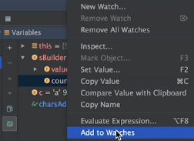 

* Watch will turn blue when the last statement executed changed its value.  
* We can simplify this even further by opening the Watches panel.  
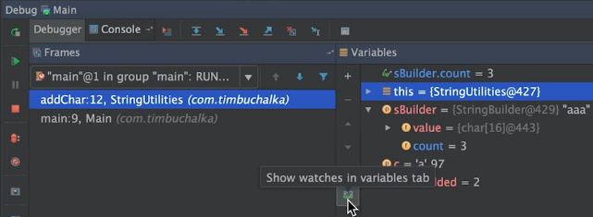  
* Once you do that, if you close it, it won’t go back to the Variables pane, to open it:  
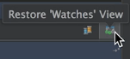  
* This will only show you the Watches you added yourself, not the ones that were set by IntelliJ.  
* Don’t confuse Watches with Field Watch Points which is our next topic.  
* **Field Watch Point** => a type of breakpoint used on a variable. Whenever the value of the variable is accessed or updated, the application will suspend  
* Let’s say we suspect that somewhere in our code the value of a variable is changing in an unexpected way and we want to locate the code that’s changing the value. We can set a Field Watch Point on that variable. Then whenever the value of the variable is accessed or updated, the application will suspend.  
=> They can be created in 2 ways:  
**1) In Editor place the cursor in the field declaration and then ALT + Click in the gutter to create the Field Watch Point there**.  
  
**2) Run => View Breakpoints… => + => Java Field Watchpoints => specify the class + variable**.  
* You can ALT + Right click to get this little menu:  
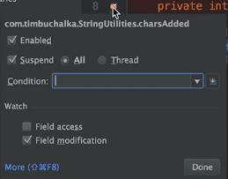

* You can also click More:  
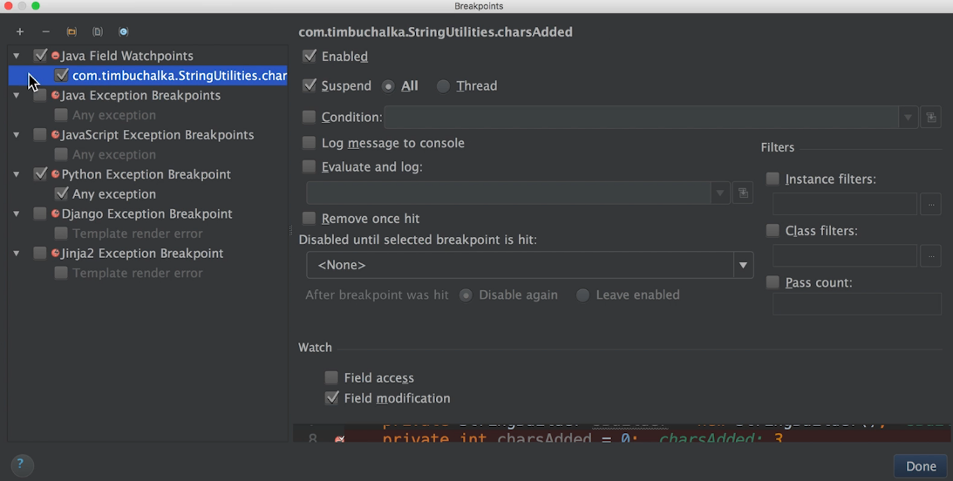  
* What I’ve shown you is probably the features that you will use for debugging probably about 99% of the time.  
* There’s a lot more we can do but settings breakpoints and watch points are really what we do the most.  
* In the next video let’s touch on a few more things.

**Advanced Debugging**  
* Let’s add a few more methods.  
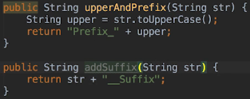  
  
* Debugger:  
  
* Step into:  
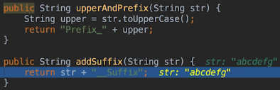  
=> Instead of stepping into the upperAndPrefix(), the debugger steps into the addSuffix() method. That’s because it’s called first on the line back in the main method.  
* In this trivial example it doesn’t matter but if you think that we had a line of code that contains calls to 4 or 5 methods, imagine the long stream chain for example and we’re interested in only that last method, it can get rather tedious to step inside and out of all the methods and worse if we accidentally hit the wrong button like Step Over, we then would have to start the debugger again.

* Let’s start the debugger again and this time let’s use something called a   
**Smart Step Into** => X, a feature of the IntelliJ debuggers. Other debuggers may not have this feature.  
* There are 2 ways we can tell IntelliJ which method we wanna Step Into.  
1) **Shift + F7** => you bring up a dialogue and you can select which method to step into.  
2) **Run => Smart Step Into**  
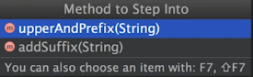  
* Another thing we can do is set variable values on the fly.  
=> Let’s say we found our bug and it’s due to a value being wrong. Now we can set the value to what we expect to see if the rest of the code executes correctly.  
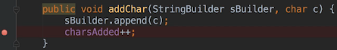  
=> **Right click the variable in the Variables panel and click Set Value…** .  
* One last thing I want to cover.  
* I mentioned earlier that we need the source code to debug a method. If we’re using a Third-party library, then we need to tell IntelliJ where it can find the source.  
* We’re not gonna use a Third-party library but let’s download a library and its source to see how to associate the source code with the library.  
* Let’s download the binary and the source:  
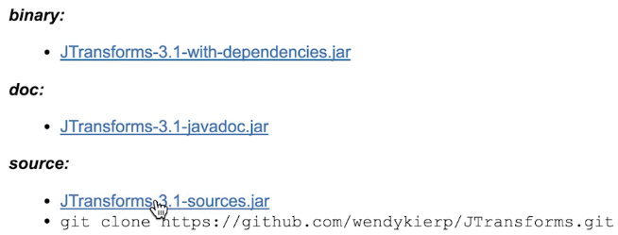  
* **File => Project Structure… => Libraries => + => Java => navigate to the file you downloaded => OK**.  
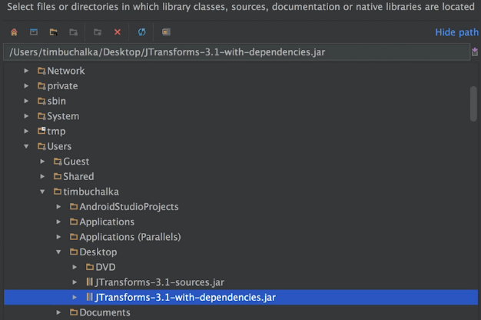

* **To add the source, click on the library in the Libraries and then the + at the bottom/top but not the one for adding a Library, the position of the + will depend on your operating system**:  
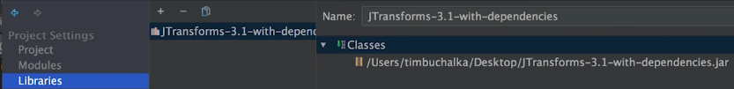  
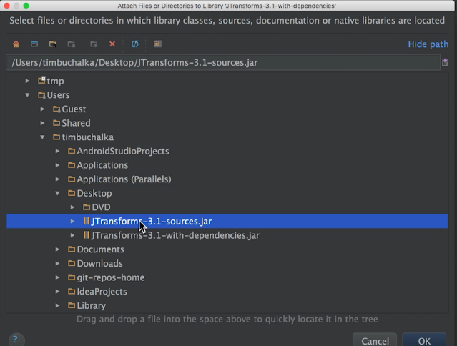  
* Now you can see it was added:  
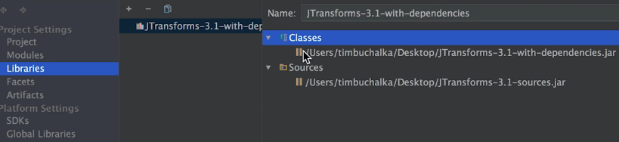  
* **The Jtransforms classes don’t contain debugger information so therefore even though we have the source, we wouldn’t be able to see much in the debugger. So it does really depend on the library. I’m just using it as an example to show you how to associate it**.  
* **If you don’t have the source code, then usually the debugger can show us the method declarations because it can figure those our from the java binary file**.

**Introduction to Unit Testing with JUnit**  
* One of the important phases in the application development lifecycle is the Testing Phase.  
* There are several types of testing.  
* **Unit Testing** => the first line of defense when testing code. Typically performed by the developer or development team.  
* When working with Java, a **Unit usually referes to a method**.  
* A developer could run tests on his code manually. For example run the method with a set of testing values and verify that we get the expected result back. But that’s tedious and what would happen if we made changes to the method? We have to run the tests all over again and perhaps add even more test values.

* **Instead of running tests manually, developers can use a Unit Testing Framework to write tests that will run in an automated fashion**.  
* When working on a team that’s coding a large application, the build process for the application will typically ruin a Unit Test Suite after each successful build and if a 100% of the tests are successful, that’s great, but if not, then the failed tests will tell the developers what recent changes to the code may have broken a part of the application.  
* For smaller applications with a single developer, the developer can still run the Test Suit right after changing any code.  
* **JUnit** is a popular testing framework that we can use to write Unit Tests.  
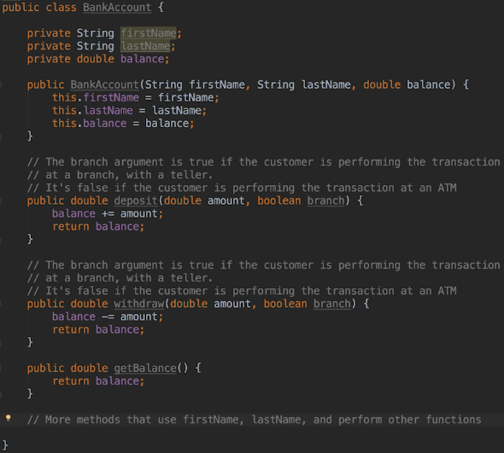  
* Let’s add the JUnit library to our project.  
* IntelliJ ships with a JUnit 3 and JUnit 4 libraries but it doesn’t add them to the projects by default.  
* We could add it the normal way:  
* File => Project Structure… => Libraries => + => Java => navigate to the IntelliJ installation folder where you find it in the libs subfolder of the IntelliJ root directory.  
* But there’s a more convenient way to add it to our project.  
=> Put your cursor on the class that you want to write tests for and press ALT + ENTER => Create Test.  
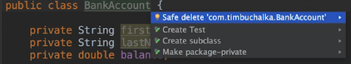  
* It’ll ask where we’re going to put the test code because what actually happens is JUnit will create for each class in your project an equivalent test class, so it’ll have the same name as the class but with a word Test in it.  
* Click on FIX if you see that JUnit library not found in the module.

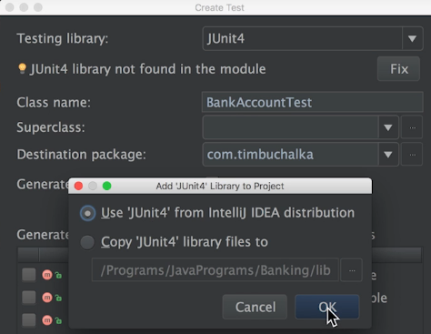  
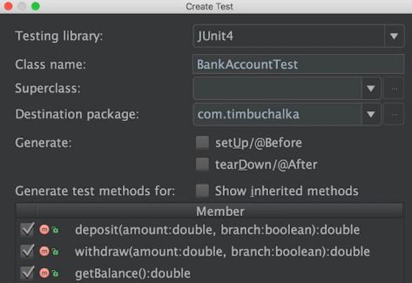  
* **It’s conventional for the Unit Testing Class to have the same name as the class that it will test**.  
  
* Notice here that there’s 1 test method for each method in the BankAccount class.  
* **Remember that a unit is typically a method and so a unit test will typically test 1 method**.  
* Right now the JUnit references are unresolved even though we added the library to our project. That’s because when we clicked the FIX button and IntelliJ added the library to our class path, it set the usage of the library to testing which means that the library will only be included when we run tests but not when we compile them.  
=> To fix this we need to go to **File => Project Structure… => Modules => JUnit4 => Test change to Compile**.  
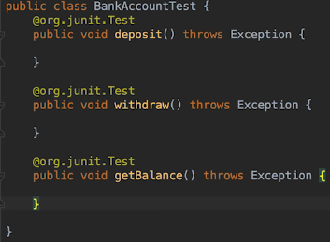 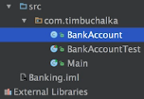

* If you want to avoid this extra step of going into the Project Structure dialogue, you can do so by not clicking the FIX when we add the library.  
* **Hover over the red unresolved `junit` and press ALT + ENTER**.  
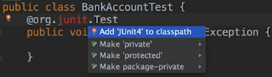  
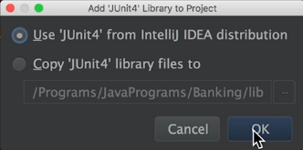  
* I prefer this method because we don’t have to go into the Project Structure at all to set the value to compile.  
* Now let’s create a separate run configuration for all our tests. Because we want to test a class in our application we don’t actually want to run the application itself. We want to run the Unit Tests.  
* Right click anywhere inside the BankAccountTest outside of any method.  
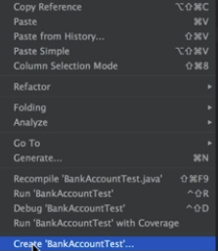  
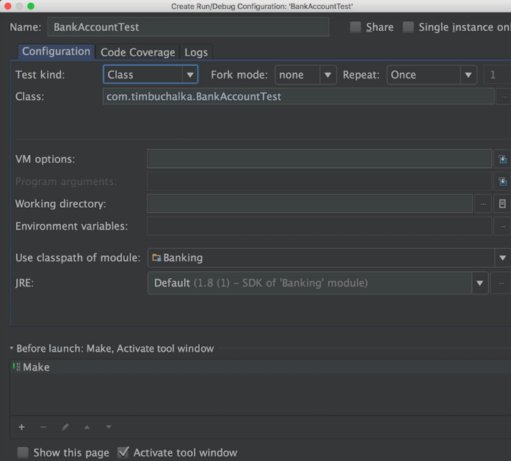

* All these options by default are correct, click on OK.  
* In the top right we can now see BankAccountTest besides the Main, next to the RUN button.  
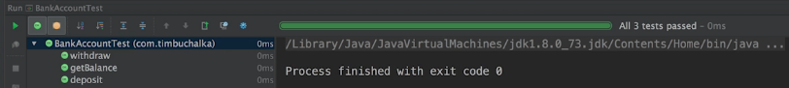  
* We haven’t written any tests yet. All we have in out BankAccountTest class are Stubs which is another word for an empty method.  
* **So a good thing to do at the start is to call** **fail()** **so that we don’t forget to write the tests**.  
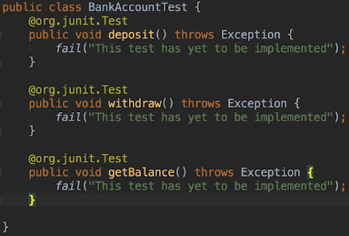  
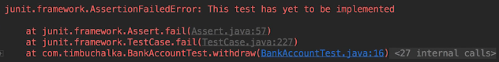  
* When we use JUnit, what we essentially do is test the output of a method against an assertion that we’ve made about the expected output. So a test fails if the assertion isn’t met.

**Asserts in JUnit**  
* The test methods must have the @org.junit.Test annotation, they must be public and return void.   
* They will usually correspond to the method names you’re testing but you can create any method.  
* When working with older Test Suites, you might see that the test methods begin with the name Test and that’s because older versions of JUnit didn’t have a test annotation so it had to have the Test name in order for the framework to identify test methods.  
* If the assertions are met, the test passed, otherwise it fails.  
* Important implication is that a test can pass even though our code has bugs because none of the tests in our test suite made an assertion that would catch the bug.  
* 1st parameter is the value we expect.  
* 2nd parameter is the value we want to test or the actual value.  
* You can use the arrow on the left in the gutter of the method to run a specific test.  
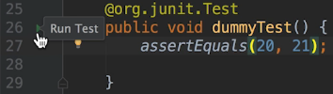  
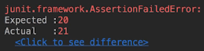

* **assertEquals()**  
* Note here that when comparing objects, the assertEquals() method uses the equals() method of the objects being compared to make the comparison.  
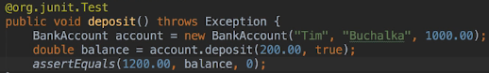  
* When comparing doubles, I’ve chosen to use the version of the method that accepts a 3rd parameter and that’s a **Delta** parameter. What that does is it allows some leeway in the comparison. So as long as the difference between the expected and actual values is within the Delta we specify, then the assertion will pass.  
* You start with Delta 0 and change it if we discovered that the value returned wasl ike 1199.9999. That sometimes happens when you’re working with double calculations.  
  
* We can have more than 1 asssertion in the test.  
* For example we may want to verify that the BankAccount balance instance variable now equals 1200.  
  
* **Every test method should be self-contained. In other words what happens in one test method shouldn’t depend on what happened in another test method. So every method should start fresh and be able to run independently of the other test methods**.  
* We can have instance variables in our test class. Depending on the code, it may make sense to create a single instance of a class that we’re testing that all the test methods use.   
* Essentially when writing a test, a question you want to ask is whether the test can run and pass on its own. And the answer to that question should always be yes.  
* So in the case of the deposit test even though we can add more than 1 assert to the samea test, it’s not best practice to do so.  
* **The best practice is 1 test per test condition or assertion**.  
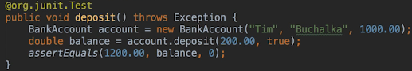  
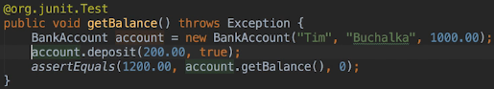  
* Let’s say we wanted to verify the value of the deposit() after calling the withdraw() method.  
=> **Doing so within the balance test method would be bad practice so we’re gonna add another method for that**.  
* Another good practice is that test method name should give some indication of the actual condition that it’s testing.  
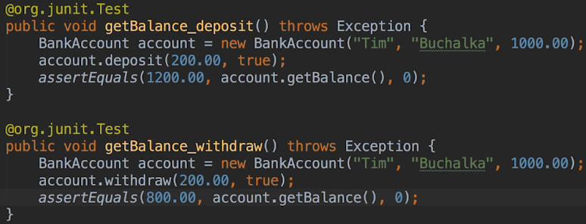  
* We can now tell from the test method name on the bottom left hand corner of the screen exactly what each method was testing.  
* One is testing the deposit method, one is verifying the balance after deposit and the others are verifying the balance after withdrawal.  
* Now let’s add a method to the BankAccount class that returns true if the account is a checking account and false otherwise.  
* We could use enum for these types of accounts but since we’ve only got 2, I’m going to use an int constant for both.  
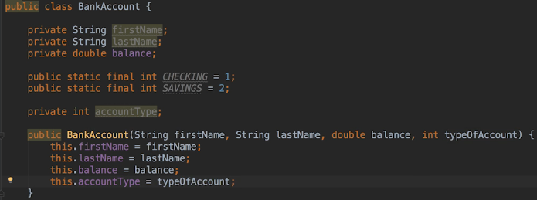  
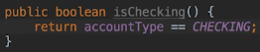  
* We can do:  
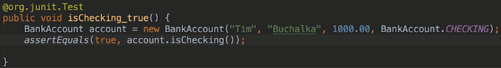  
* But when you’re testing a value against true/false, it’s preferrable instead of using assertEquals() to use **assertTrue()** or **assertFalse()**.  
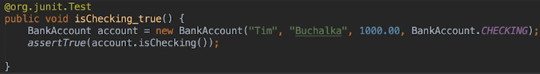  
* So clicking on these tests that have failed or succeeded is not really very useful for small test suites and tests that only got 1 assertion but when skimming the results of a large test suite or when we’ve got tests that are performing more than one assert() call, then the messages can be really helpful.  
* **Keep in mind that sometimes JUnit tests are being run as part of the build process and not manually. So as part of that, failed test results may be saved to a file or a human might have to look at the results which could be numerous and that’s when these messages can be really quite useful**.

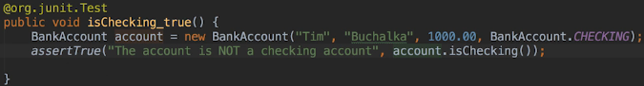  
* As part of a big software team or if the unit tests are being performed as part of the build process, these types of messages can be really useful to help a developer figure out what changes need to be made.

**More Asserts and Exception Handling**  


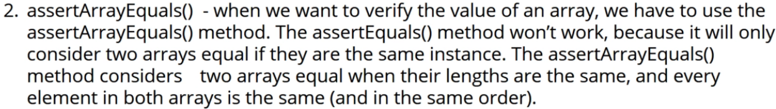

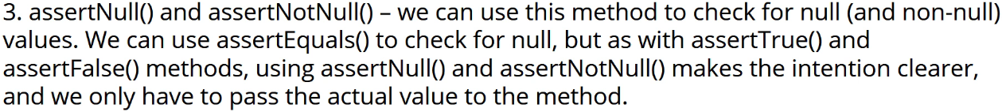

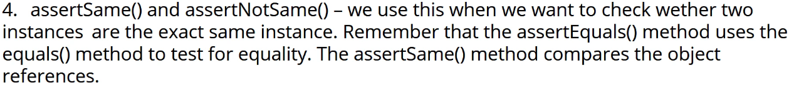

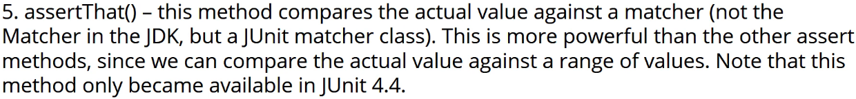  
* Instead of writing the same line of code in each test (for example to create a BankAccount instance), we can use a method that has the   
**@org.junit.Before annotation** => **That kind of method is run before every test**.  
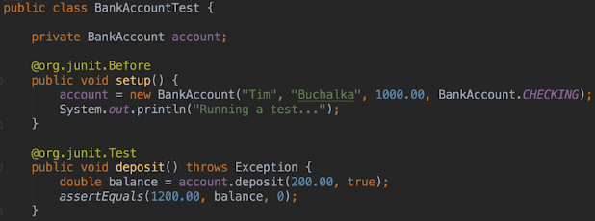  
* **What about the case where we want to perform some setup() code before the tests but we only want the setup code to be run once**. In other words, we don’t want to run it before every test.  
* And example of that might be **when we want to read data that all the tests will use from a database or file. Or perhaps we may want to open a network socket or do some other setup that we really want to do once per run**, instead of once per method invocation.

* **@org.junit.BeforeClass annotation** => **run before all the tests in the test class have completed**.  
* **@org.junit.AfterClass annotation** => **run after all the tests in the test class have completed**.  
* They have to be **public static void**.  
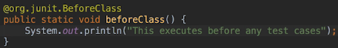  
* I normally like to put the BeforeClass and Before methods at the top of the file and the AfterClass and After at the bottom of the file.  
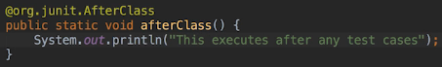  
* The names of the methods are not important, the Annotation is what JUnit is using.  
* **Depending on the timing, the statement printed by BeforeClass may actually appear in the console after the statement printed from the setup method**.  
=> **This doesn’t reflect the order of execution**.  
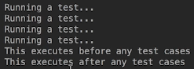  
* What is happening is that the print statements are spooled to an IO Thread and so they may appear in the console out of order.  
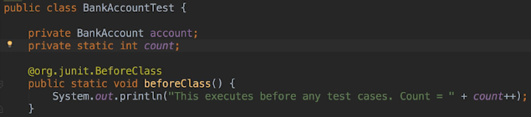  
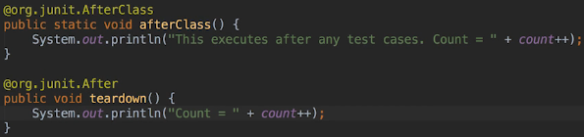  
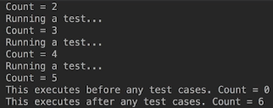  
* **So even though the output is showing in a different order, the methods are being run in the order that we specified**.

* Let’s use the branch parameter now:  
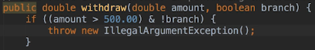  
**!!! should be && and not &**  
* Let’s modify our tests:  
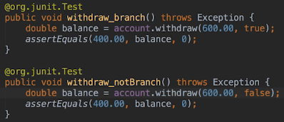  
* This throws an exception. When we’re expecting an exception to be thrown, we actually have to make a modification to the annotation for the method.  
* **expected**  
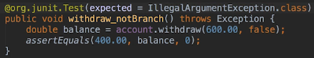  
* In the next video we’re gonna come up with another little bit of a scenario to optimize this withdraw_branch method and I’m gonna show you the old way of testing exceptions that you used to have to do in older versions of JUnit.

**Parametrized Testing**  
* We can optimize this method a little bit more.  
* **If we’re expecting an exception to be thrown, we’d have to modify the annotation line as you saw**.  
=> **We can also remove the assertEquals as well because we’re not testing for equality in this case, we’re just testing to see whether the exception is thrown. And we can remove that local variable as well because we don’t need that**.  
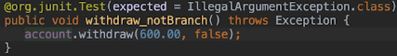  
* Annotations were introduced in JUnit 4.  
* When using earlier versions of JUnit, we would have to surround the code that would throw an exception with a TRY CATCH block and we wouldn’t do anything in the CATCH block.  
* Remember that if you don’t assert anything, the test will pass.  
* I just want to show you because you might come across code that still uses it.  
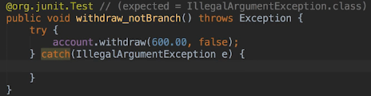  
* The other thing I wanted to show you - what we should really be doing here to be more specific if have a fail() here as well.

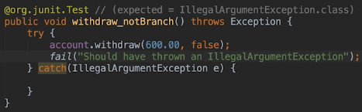  
* **That’s how we would have had to do it in the past**. It’s a lot easier these days:  
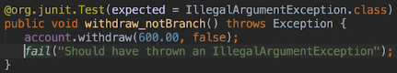  
* **Parameterized Test** => The final JUnit topic that I want to cover is Parametrized Tests.  
=> We want every test to start fresh but that can result in a lot of repetitive code.   
=> For example let’s suppose we want to try depositing 5 different amounts and verying the resulting balance.  
=> We could write 5 different test cases but we can also write a parameterized test.   
=> We have to use a class Annotation to run parameterized tests.  
=> We need to tell JUnit that this isn’t a normal test class. We want to tell it that we want to use it to run a parameterized test so we need to use the @ run with annotation on the class definition itself.  
* **@RunWith(Parameterized.class)**  
* You should see 2 little green arrows in the gutter to the left of the class definition.  
* **@Parameterized.Parameters**  
* The method needs to return a Collection.  
* It’s sets of parameters we want to test followed by the expected value.  
* **When we run the parameterized test, JUnit fill create a new instance of the BankAccountTestParameterized class for each set of test data**.  
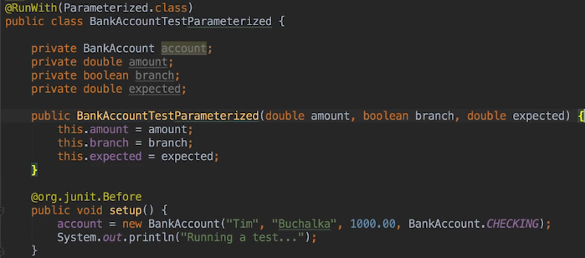  
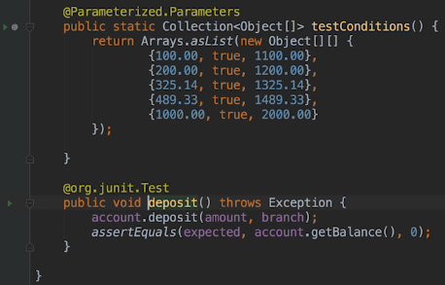

* We can run it by clicking the green arrow in the gutter of the deposit() method.  
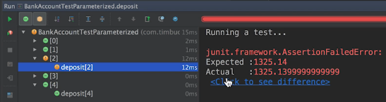  
=> **This is where the Delta option comes in**.  
* **Delta .01**  
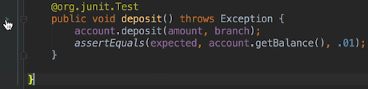  
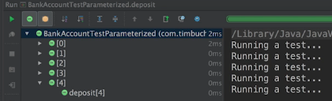  
* The indexes of the tests are coming from the Collection.  
* This time we allowed the delta to be .01 which is enough now to actually cover for the fact that it was so close enough dealing with the double precision that is part of the double primitive type.  
* In most cases you won’t need to do that but you can see where the delta option comes into play if you do need to do that when you’re testing double primitive type.  
* Alright so that’s how we run a bunch of tests on the same method.  
* **There was a bit of work to set it all up but then it does cut down on the amount of test code that we have to maintain**.  
* **Now that you’ve seen how JUnit gets the test values and passes them to the test method, hopefully now you can understand why we have to create a class for each parameterized test that we want to run**.  
* There’s certainly more that you can do with the framework but you now have the basics and coupled with you spending some time looking at the documentation and playing around with it, I’m sure you’ll get a lot out of it.

**JUnit Challenge #1 and #2**  
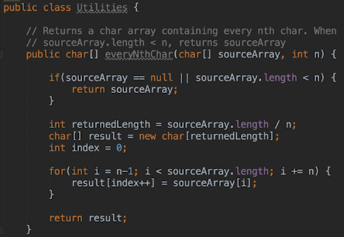  
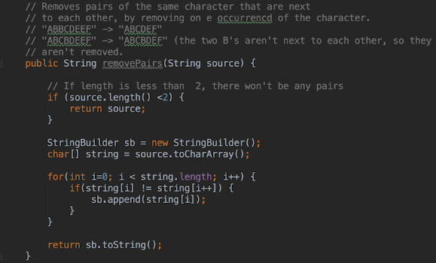  
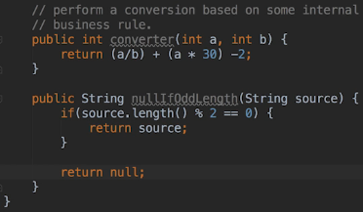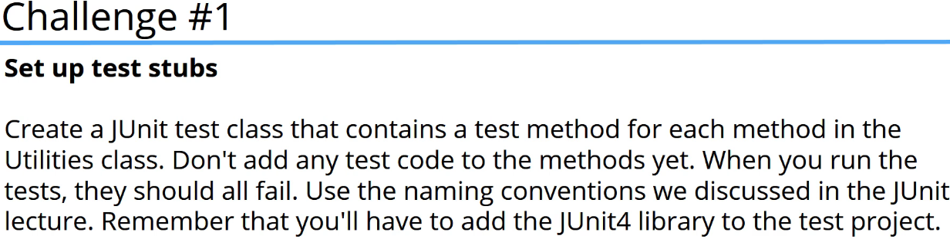

=> **ALT + ENTER on the Utilities class**  
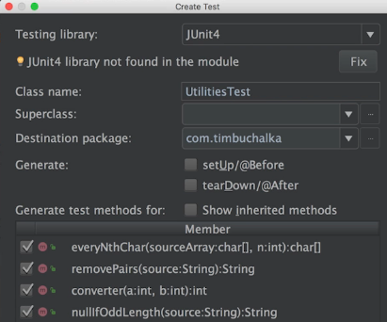  
=> **ALT + ENTER on the unresolved junit**  
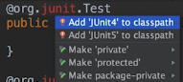  
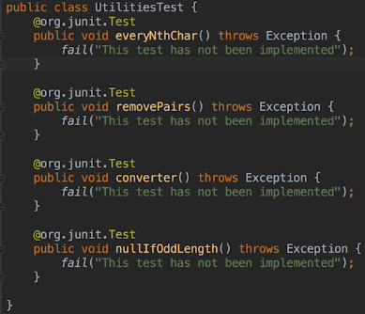  
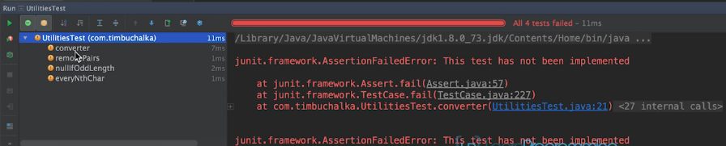  
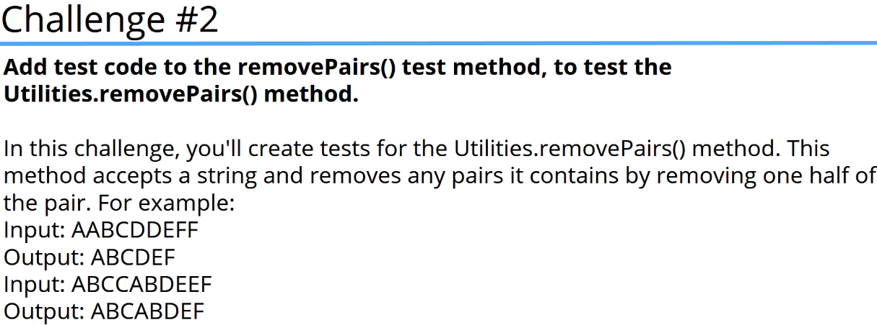

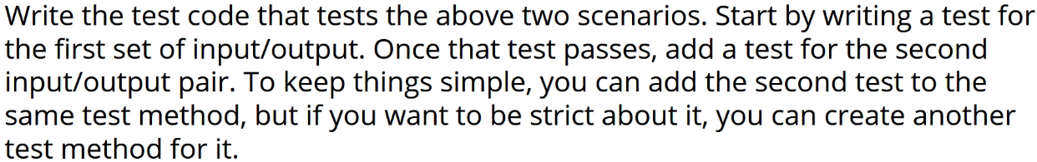  
* For this particular challenge we wanna use the assertEquals() method and that’s because we want to test the actual value, the output from the method, against the expected value.  
* **Remember that the expected value is the 1st parameter**.  
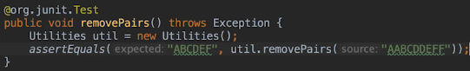  
* We can click RUN to run all the tests.  
* Or we can click in the gutter to run a specific test.  
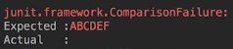  
* Let’s debug it. You can use the Debugger or use prints.  
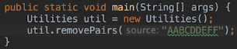  
**\* Some developers prefer using logging or println when when they know the general area where the bug must be and then if the prints don’t help, they then use the debugger**.  
* **Note, however, that you’ll often need to use the debugger when working on non-trivial applications**.  
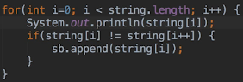   
* The i++ not only increments the `i` but also assigns the result back to `i` and that’s why we’re actually skipping over characters.  
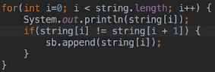  
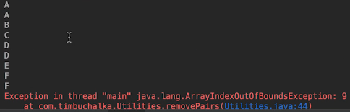  
=> **One bug masking another bug is a very common scenario.**  
=> We need to stop at string length -1.  
=> We also need to add the last character because that character is always safe. If it was a part of the pair, we already handled the pair by not adding the first character of the pair.  
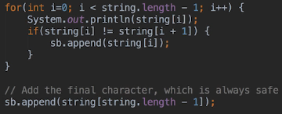  
* Let’s also add the second test.  
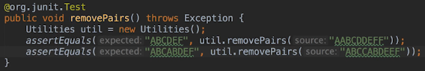  


**JUnit Challenges #3 to #7**  
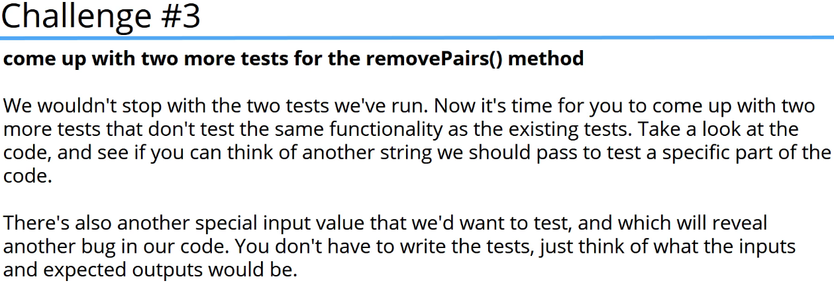  
* Right now passing NULL would crash because we’re not testing for NULL.  
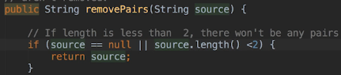  
* For simplicity of this challenge, I’m putting all of them in 1 test.  
* **assertNull()**  
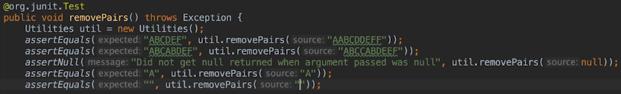  
* This would be something that you find does happen when you’re creating unit tests - you’ll be thinking of conditions and then you’ll realize that you haven’t tested for a particular scenario.  
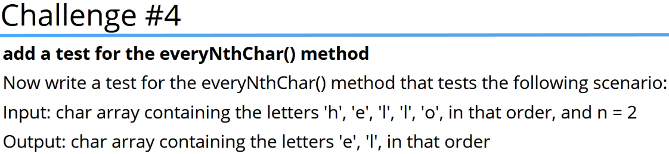  
* **When testing arrays, the assertEquals() method only returns true if the arrays are the exact same instance**.

* Click on import static method if it doesn’t come up.  
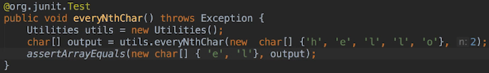  
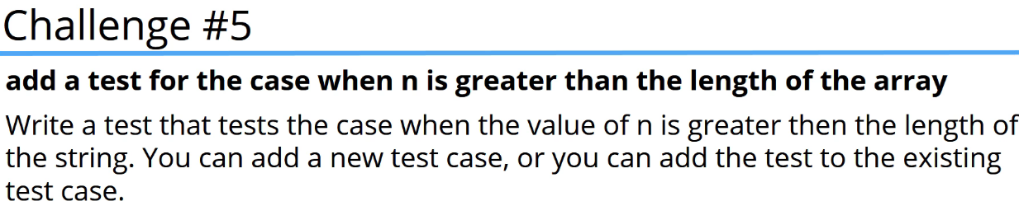  
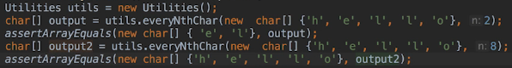  
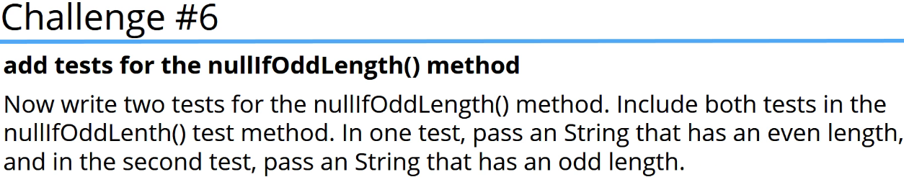  
* **assertNotNull()**  
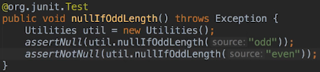  
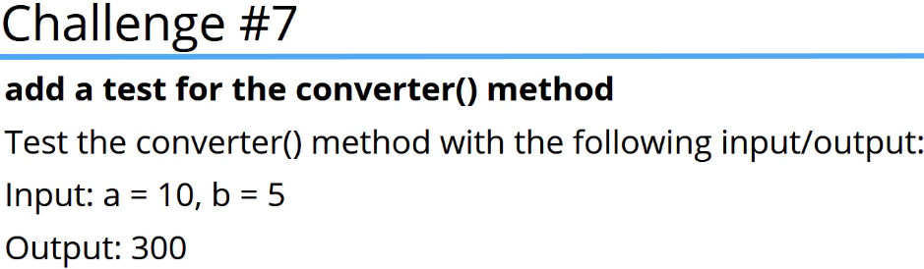  
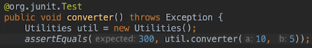

**JUnit Challenges #8 to #10**  
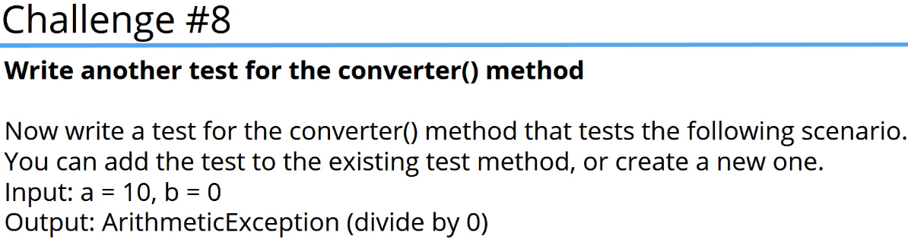  
* **We can’t put it in the same test method because we’re expecting an Exception to be thrown**.  
* If we were to put both tests in the same method, it’s possible that the test method as a whole would pass even though one of the asserts was failing.

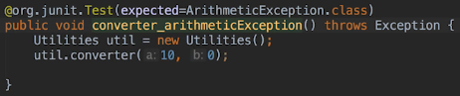  
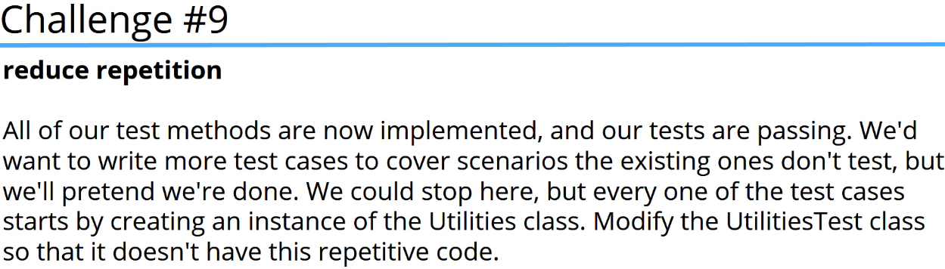  
* Since the @Before method will run before every test case, every test method will start with a fresh instance of the Utilities class.  
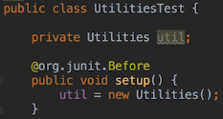  
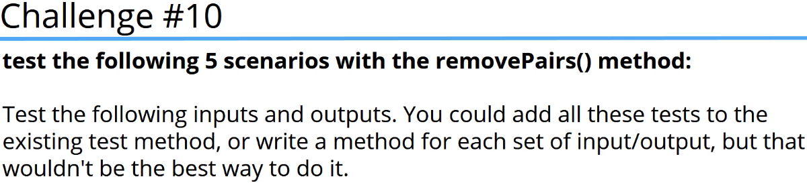

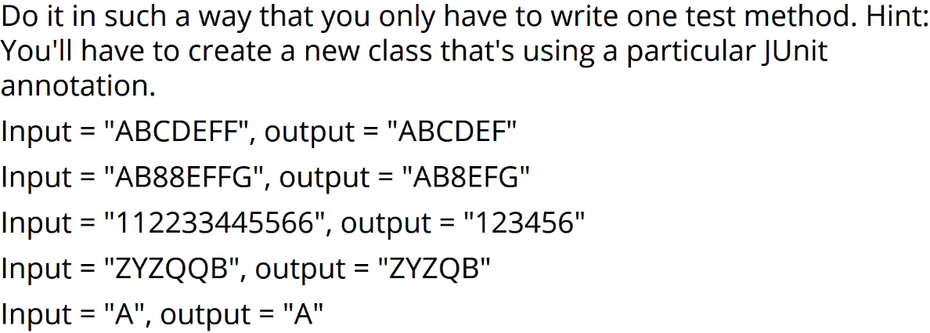  
* The solution calls for Parameterized Test so we’re going to create a new test class called UtilitiesTestParameterized and annotate it with the **@RunWith(Parameterized.class)** annotation.  
* We’re going to declare some instance variables for the Utilities instance, the input value for each test as well as the expected value for each test. And we’ll also declare a constructor that will accept the expected value - the output and the string parameter - the input.  
* Remember that for each set of test data, JUnit will create a new instance of the class and pass the expected and actual values to the contructor.

* **@Parameterized.Parameters**  
* **@org.junit.Test**  
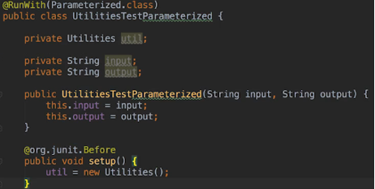  
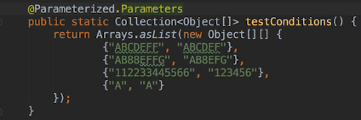  
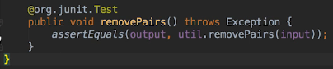  
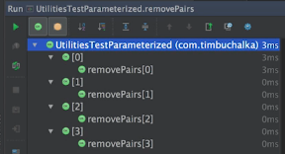

**Resources**  
Jtransforms  
<https://sites.google.com/site/piotrwendykier/software/jtransforms>